**Library Management System**

**Name**:- Tejashree Prakash Nyaynirgune.

Project Output:

Main Dashboard

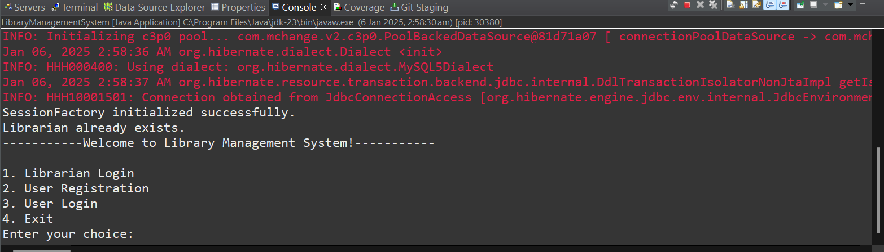

1) Librarain Login:-

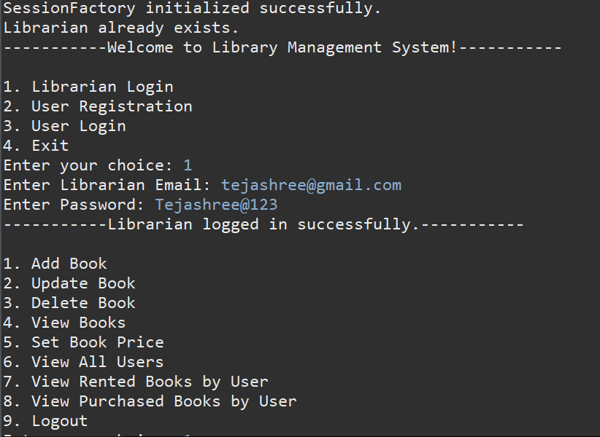

1)Add Book With validation:-

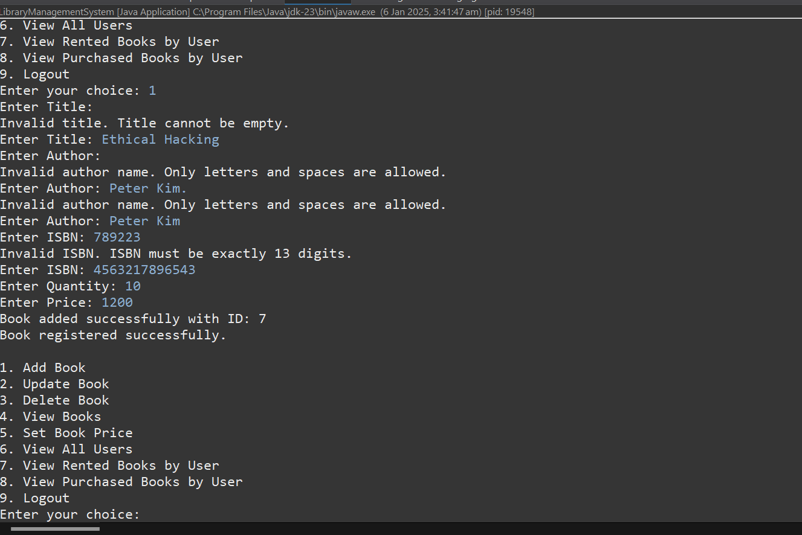

2)Update the book with validation

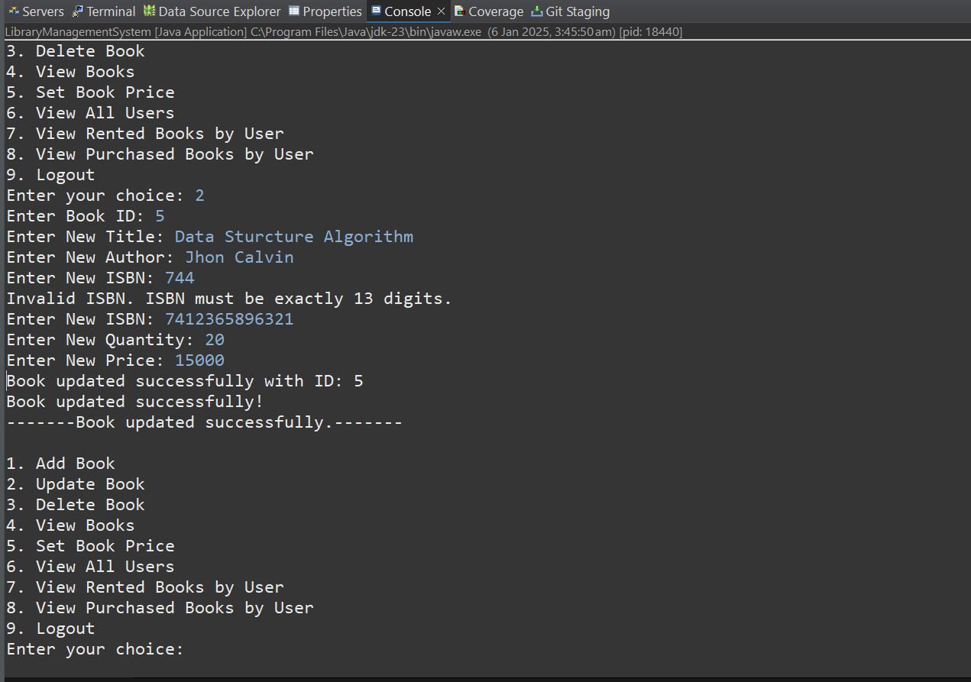

3)Delete the book:

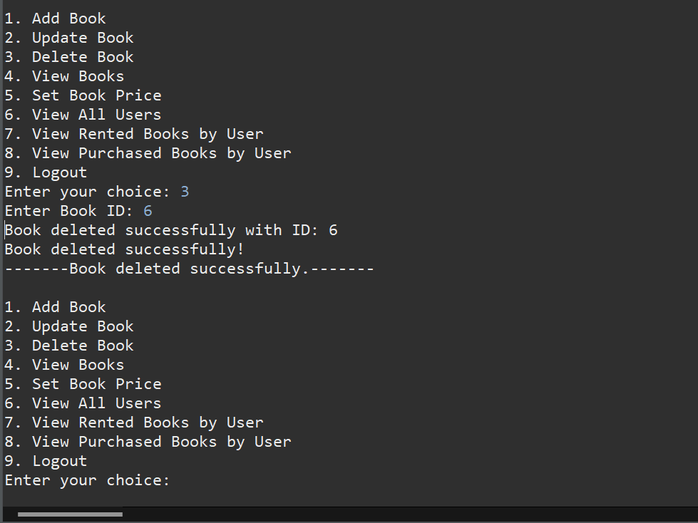

4) View Books:

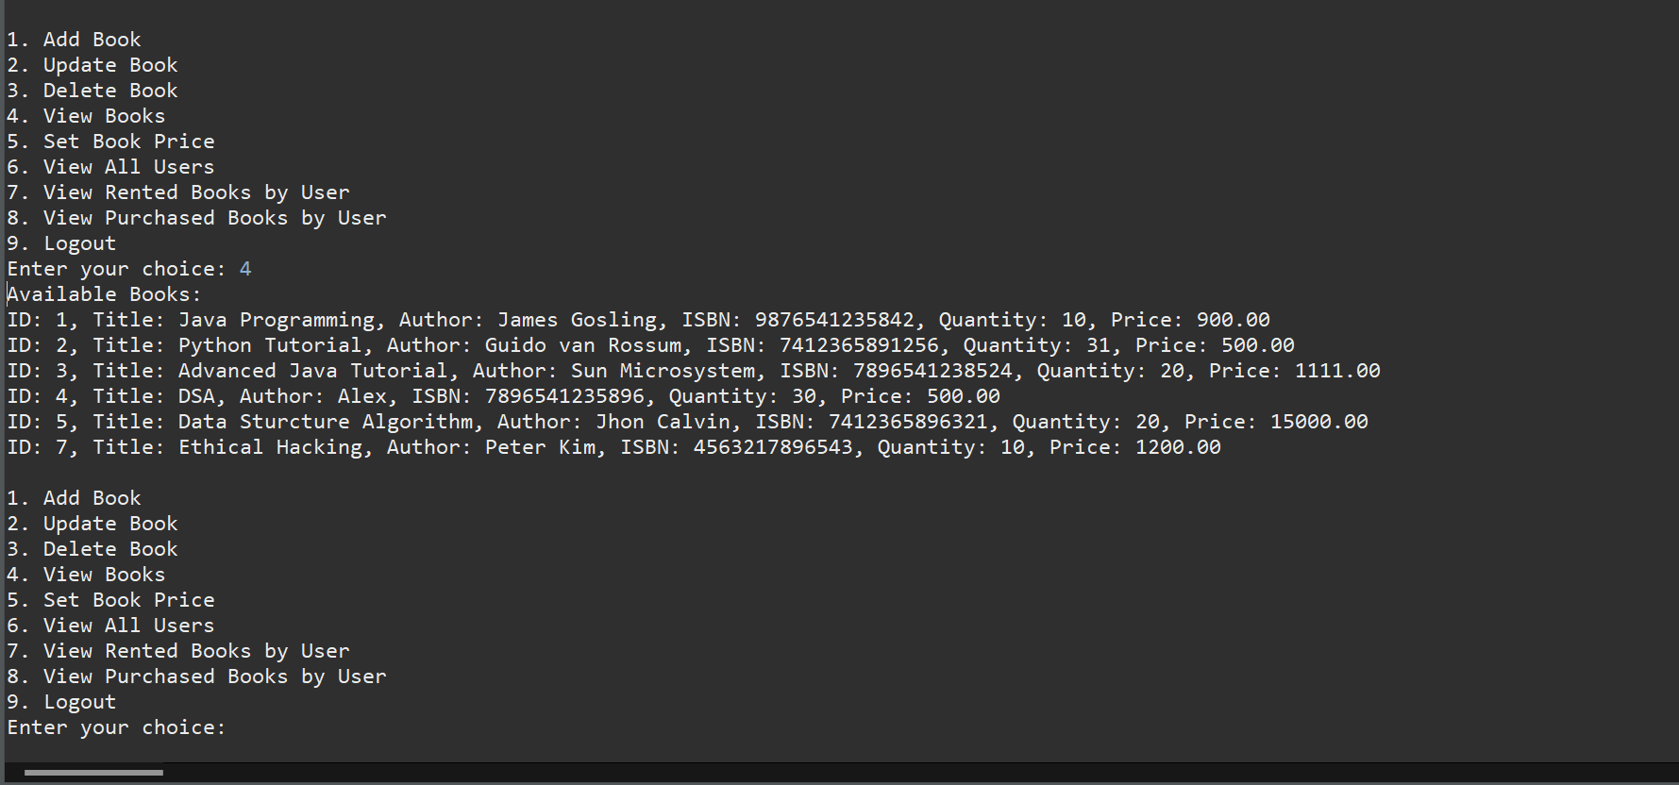

5)Set Price

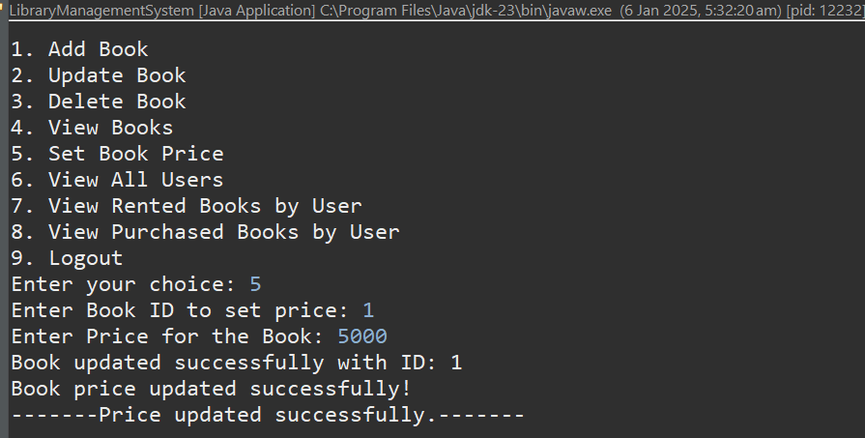

6) View All Users

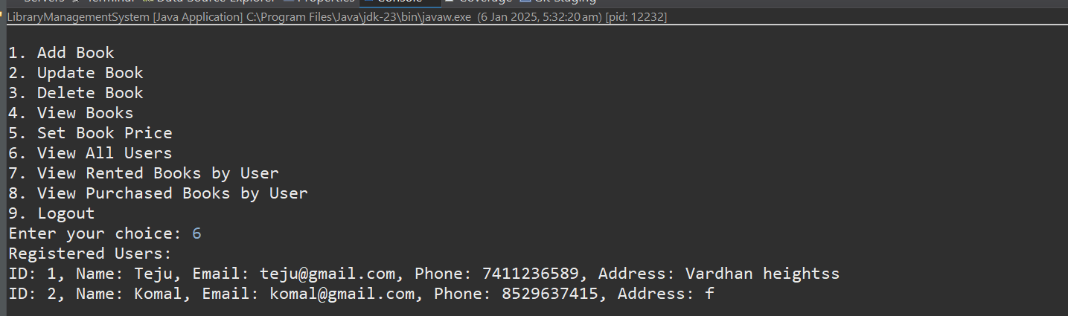

7) View Rented Books By User

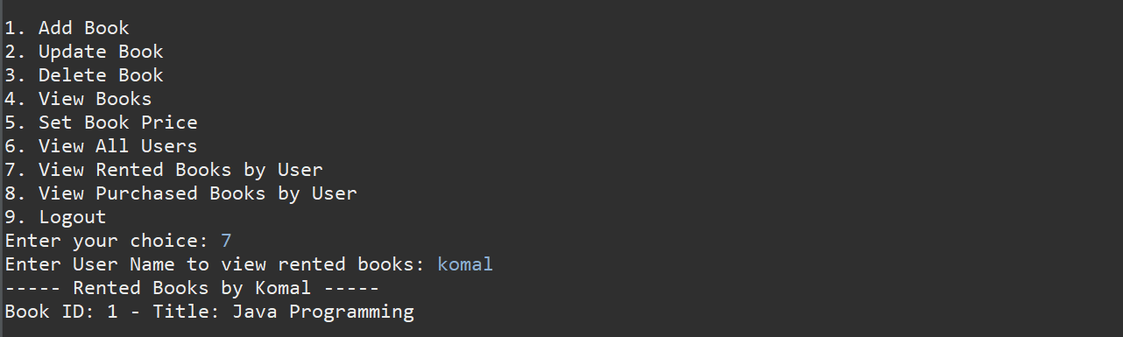-

8) View Purchased Books by User

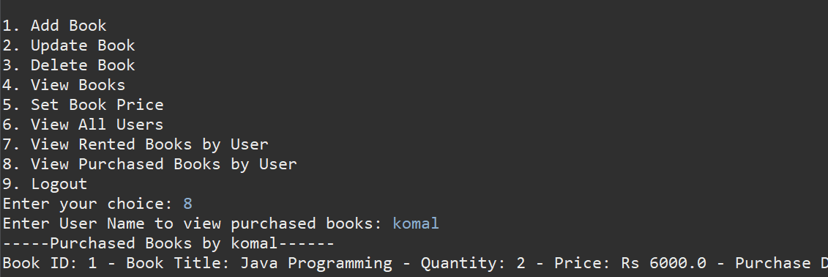

--------------------------------------------------------------------------------------------------------

2) User registration with validations

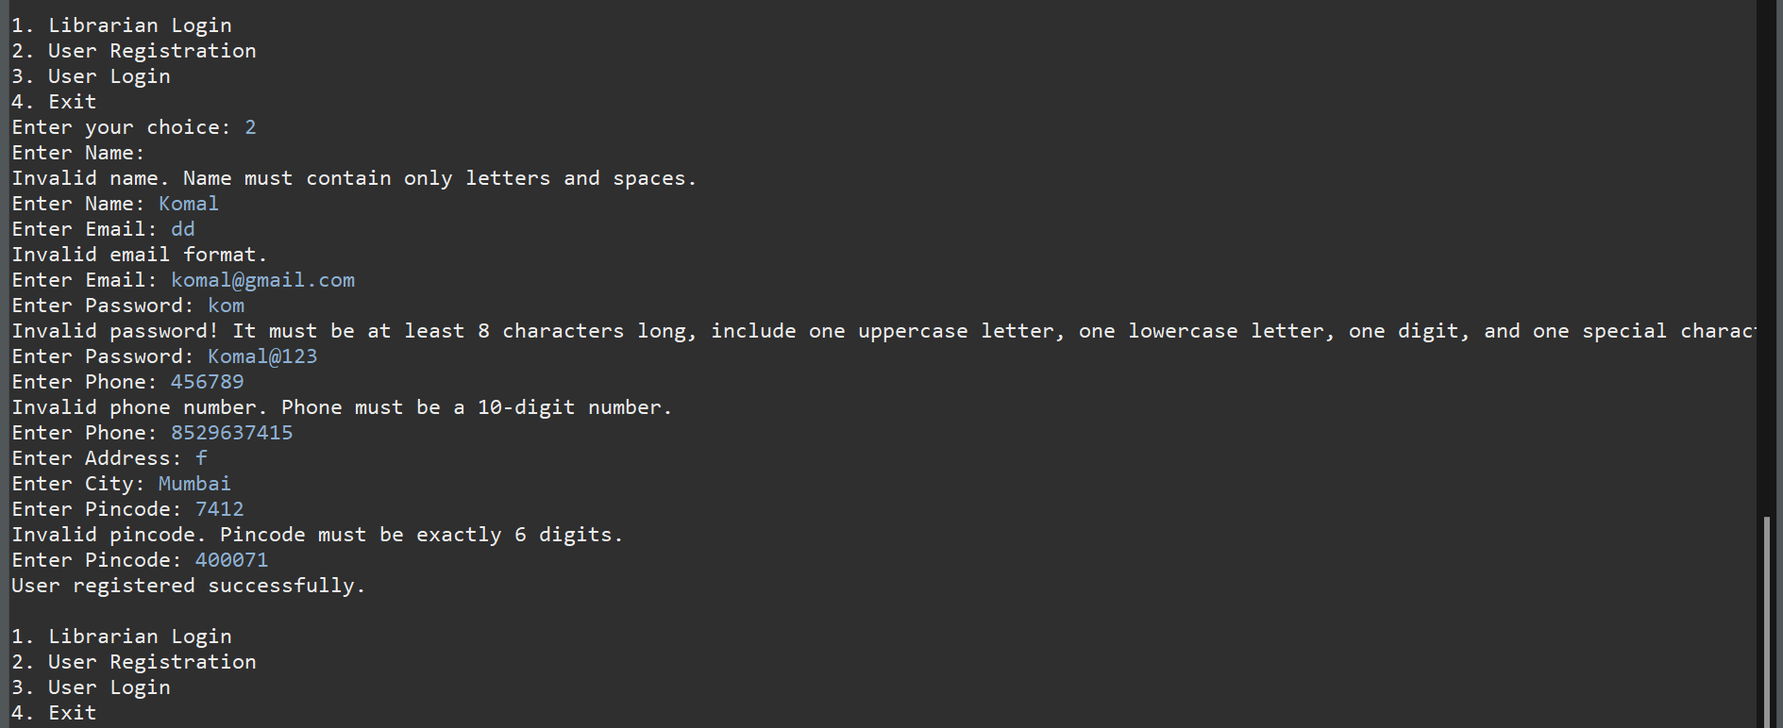

3)User login

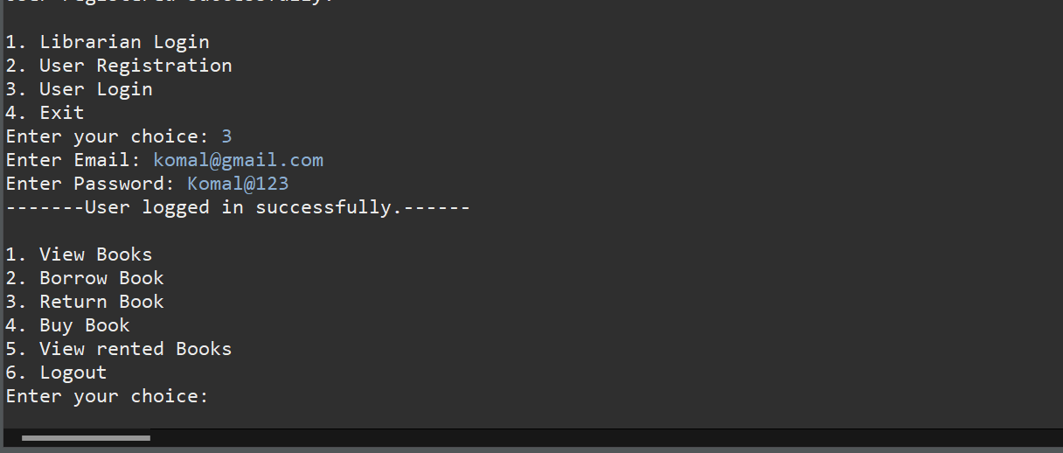

1)view book:

2)Borrow Book:

3) Return Book

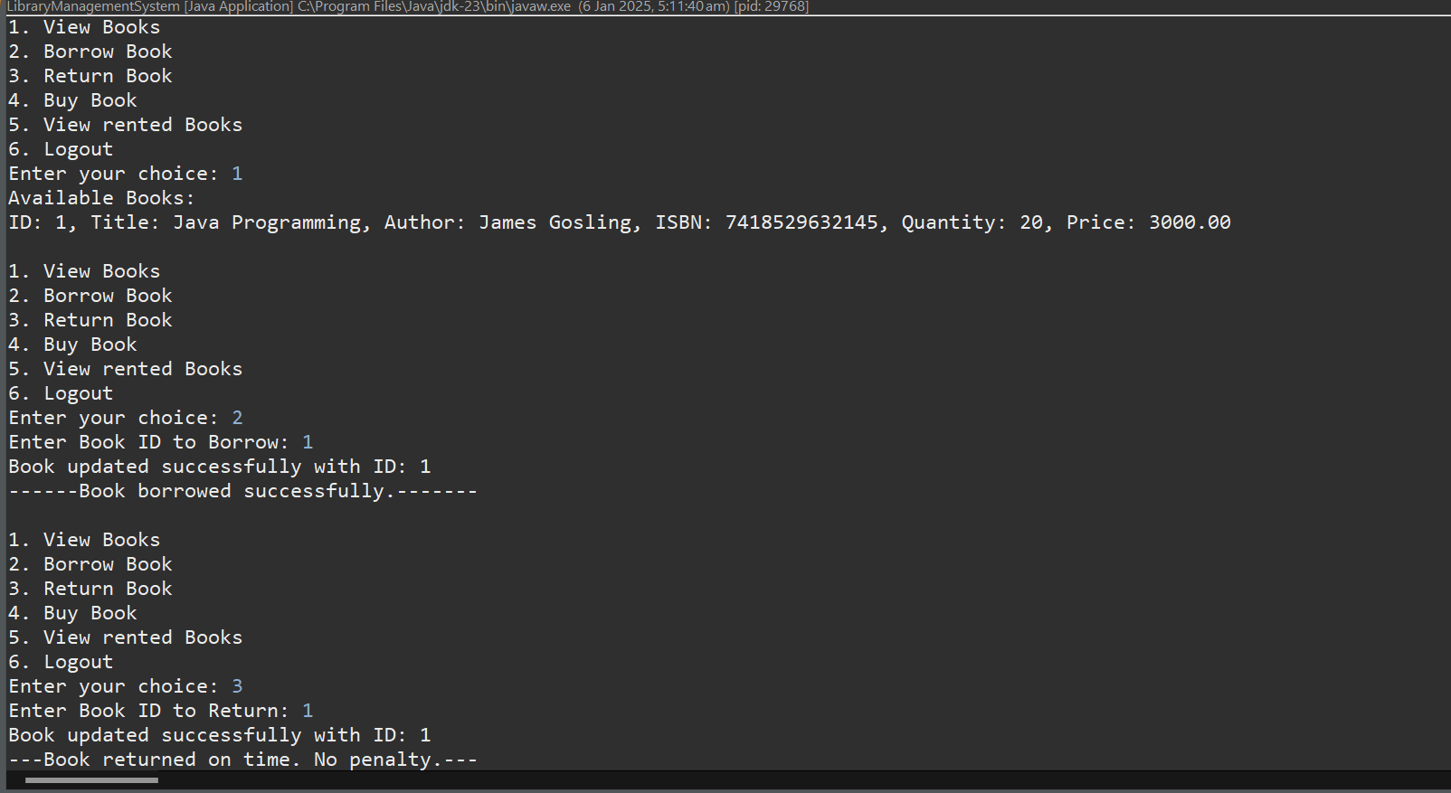

4) Buy Book:

5)View rented Book

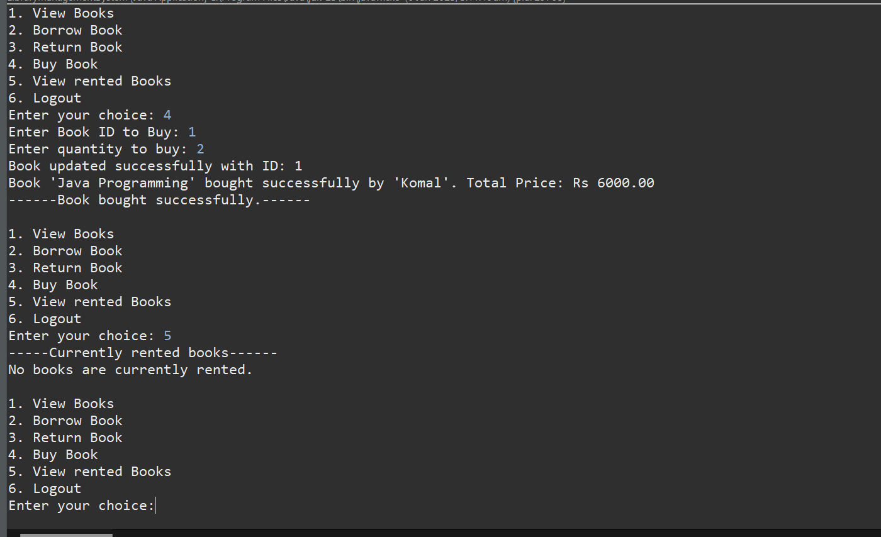

6)Log out

4)Exit (from Libraray Managemnet System)

